**JAVA RECORD BOOK-2**

**LAB PROGRAM 6**

Create a package CIE which has two classes- Student and Internals. The class Personal has members like usn, name, sem. The class Internals has an array that stores the internal marks scored in five courses of the current semester of the student. Create another package SEE which has the class External which is a derived class of Student. This class has an array that stores the SEE marks scored in five courses of the current semester of the student. Import the two packages in a file that declares the final marks of n students in all five courses.

* HANDWRITTEN PROGRAM

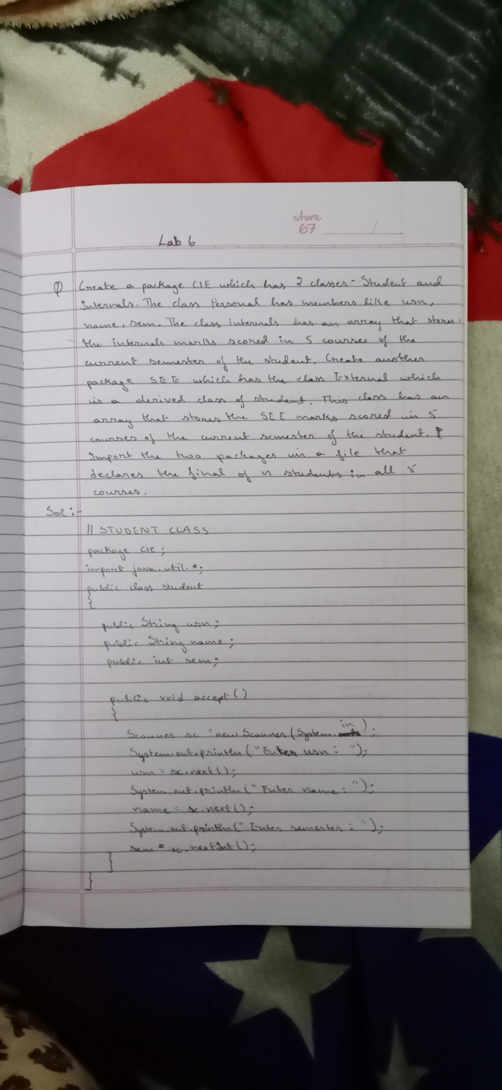

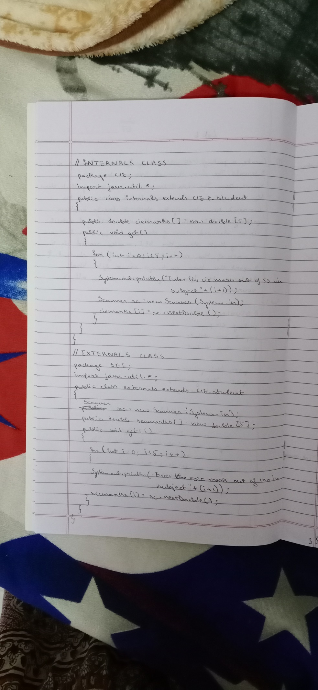

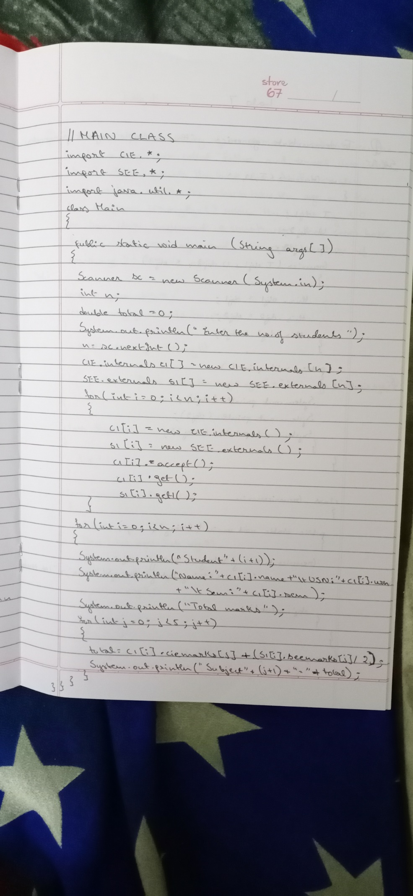

* PROGRAM

//STUDENT CLASS

package CIE;

import java.util.*;

public class student

{

public String usn;

public String name;

public int sem;

public void accept()

{

Scanner sc = new Scanner(System.in);

System.out.println("Enter usn:");

usn=sc.next();

System.out.println("Enter name:");

name=sc.next();

System.out.println("Enter semester:");

sem=sc.nextInt();

}

}

//INTERNALS CLASS

package CIE;

import java.util.*;

public class internals extends CIE.student

{

public double ciemarks[] = new double[5];

public void get()

{

for(int i=0;i<5;i++)

{

System.out.println("Enter the cie mark out of 50 in subject"+(i+1));

Scanner sc = new Scanner(System.in);

ciemarks[i]=sc.nextDouble();

}

}

}

//EXTERNALS CLASS

package SEE;

import java.util.*;

public class externals extends CIE.student

{

Scanner sc = new Scanner(System.in);

public double seemarks[] = new double[5];

public void get1()

{

for(int i=0;i<5;i++)

{

System.out.println("Enter the see mark out of 100 in subject"+(i+1));

seemarks[i]=sc.nextDouble();

}

}

}

//MAIN CLASS

import CIE.*;

import SEE.*;

import java.util.*;

class Main

{

public static void main(String args[])

{

Scanner sc = new Scanner(System.in);

int n;

double total=0;

System.out.println("Enter the number of students");

n=sc.nextInt();

CIE.internals c1[]=new CIE.internals[n];

SEE.externals s1[] = new SEE.externals[n];

for(int i=0;i<n;i++)

{

c1[i]=new CIE.internals();

s1[i]=new SEE.externals();

c1[i].accept();

c1[i].get();

s1[i].get1();

}

for(int i=0;i<n;i++)

{

System.out.println("Student"+(i+1));

System.out.println("Name:"+c1[i].name+"\tUSN:"+c1[i].usn+"\tSEM:"+c1[i].sem);

System.out.println("Total Marks");

for(int j=0;j<5;j++)

{

total=c1[i].ciemarks[j]+(s1[i].seemarks[j]/2);

System.out.println("Subject"+(j+1)+"="+total);

}

}

}

}

* OUTPUT

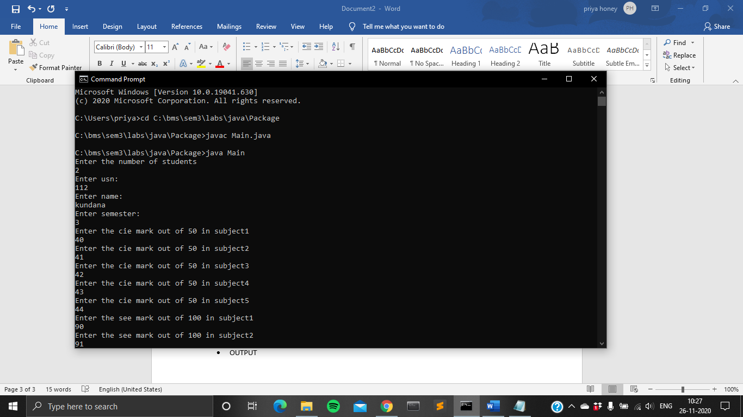

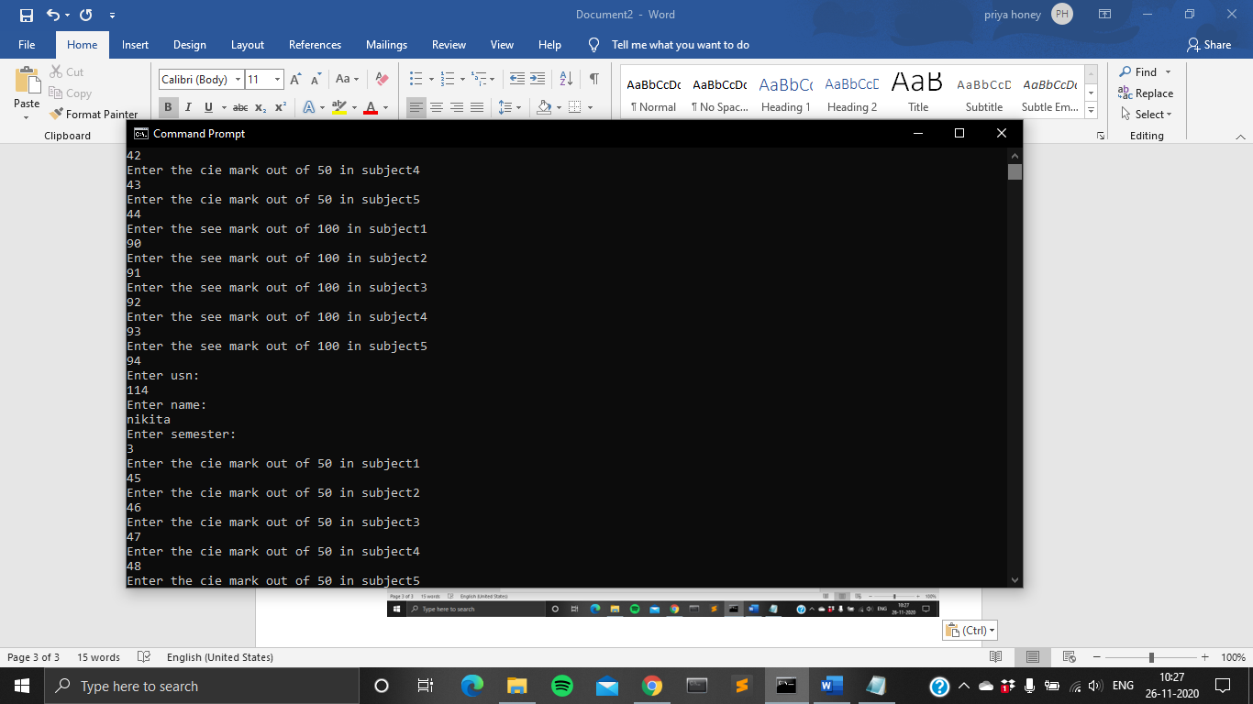

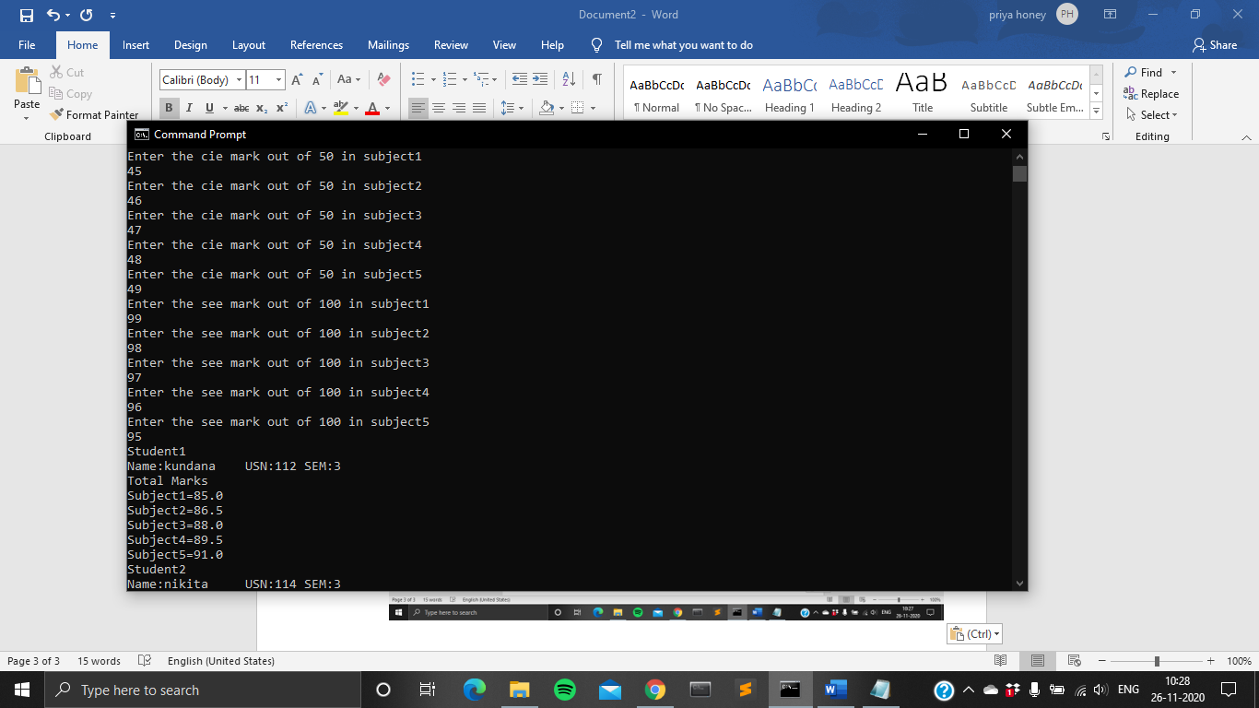

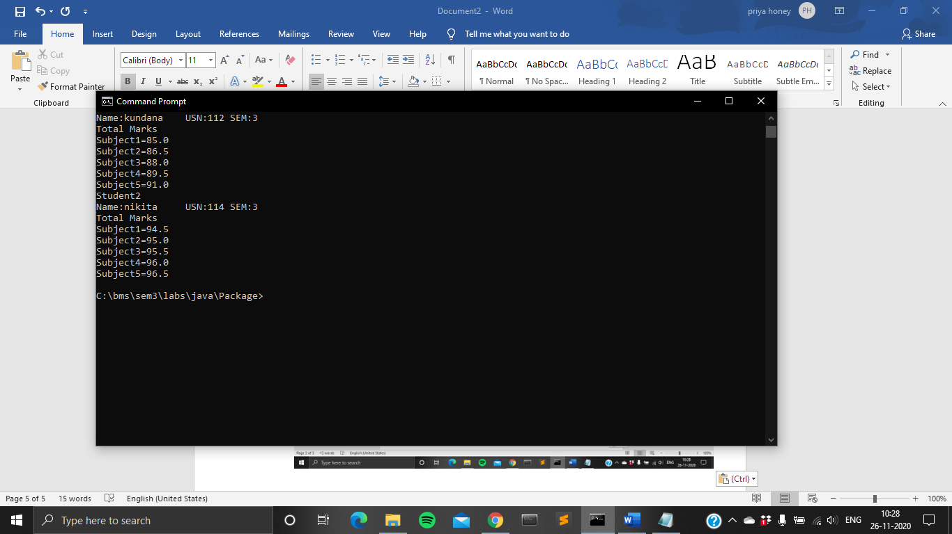

**LAB PROGRAM 7**

Write a program to demonstrate generics with multiple object parameters.

* HANDWRITTEN PROGRAM

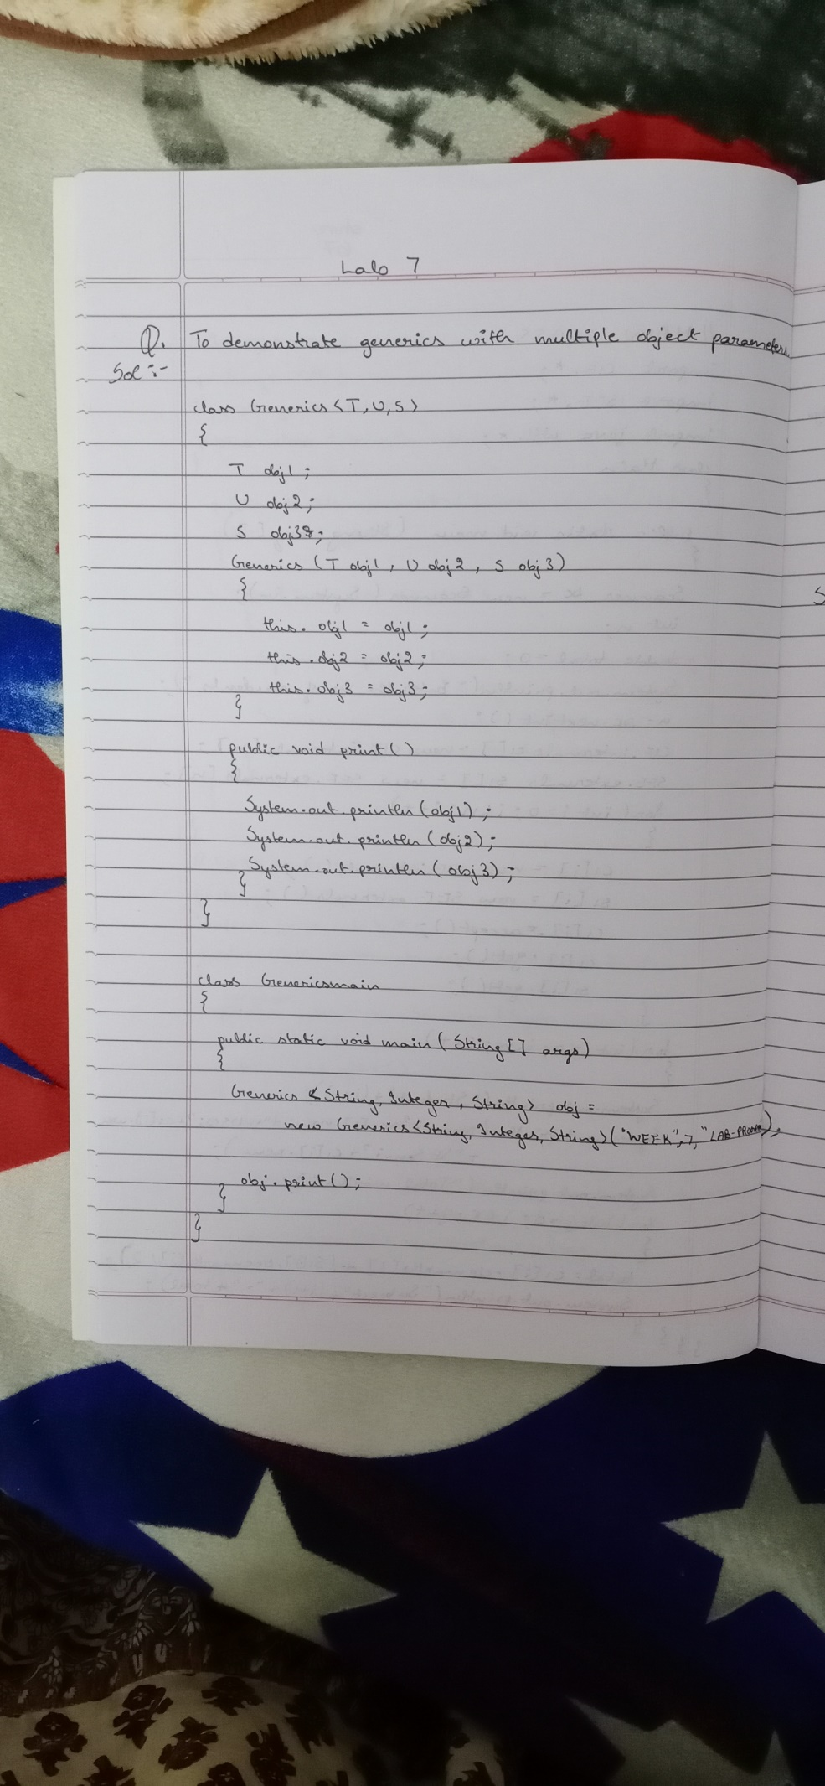

* PROGRAM

class Generics<T, U,S>

{

T obj1;

U obj2;

S obj3;

Generics(T obj1, U obj2,S obj3)

{

this.obj1 = obj1;

this.obj2 = obj2;

this.obj3 = obj3;

}

public void print()

{

System.out.println(obj1);

System.out.println(obj2);

System.out.println(obj3);

}

}

class Genericsmain

{

public static void main (String[] args)

{

Generics <String,Integer, String> obj =new Generics<String, Integer,String>("WEEK", 7,"LAB-PROGRAM");

obj.print();

}

}

* OUTPUT

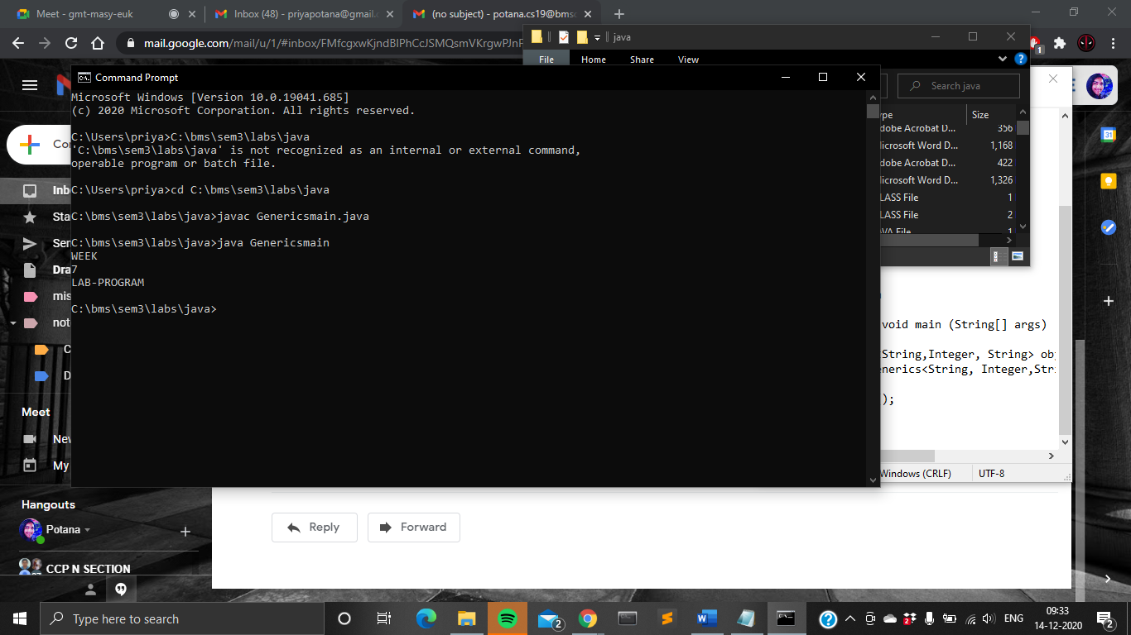

**LAB PROGRAM 8**

Write a program that demonstrates handling of exceptions in inheritance tree. Create a base class called “Father” and derived class called “Son” which extends the base class. In Father class, implement a constructor which takes the age and throws the exception WrongAge( ) when the input age<0. In Son class, implement a constructor that cases both father and son’s age and throws an exception if son’s age is >=father’s age.

* HANDWRITTEN PROGRAM

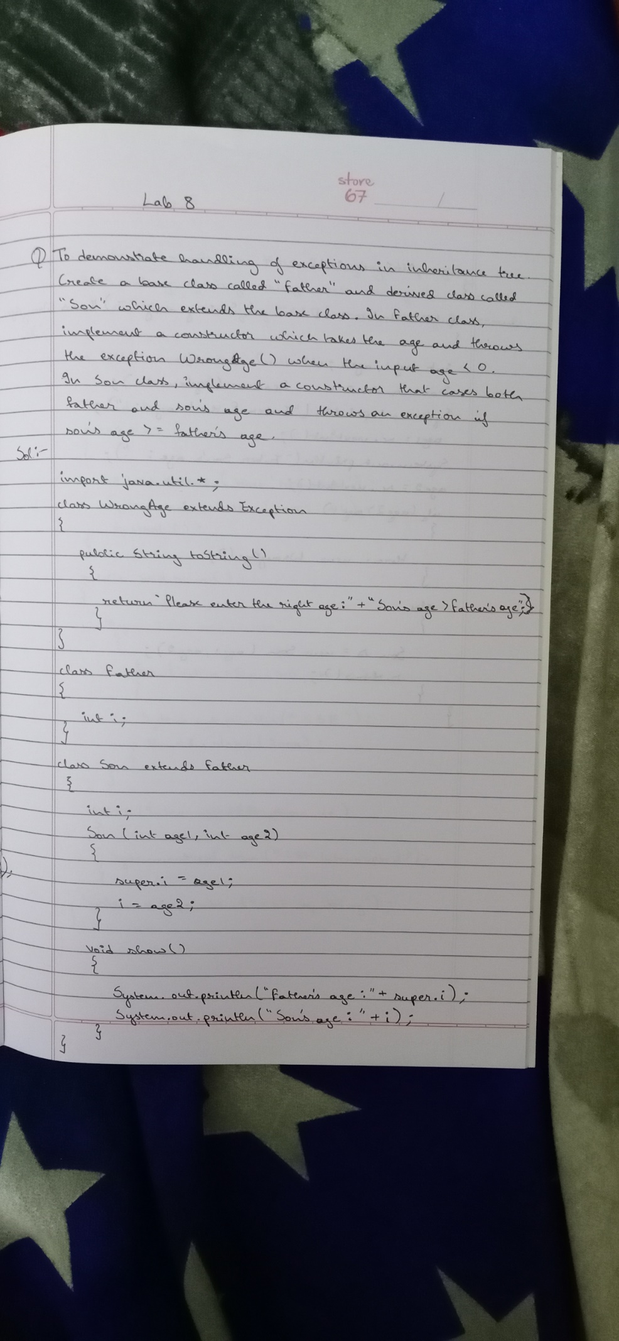

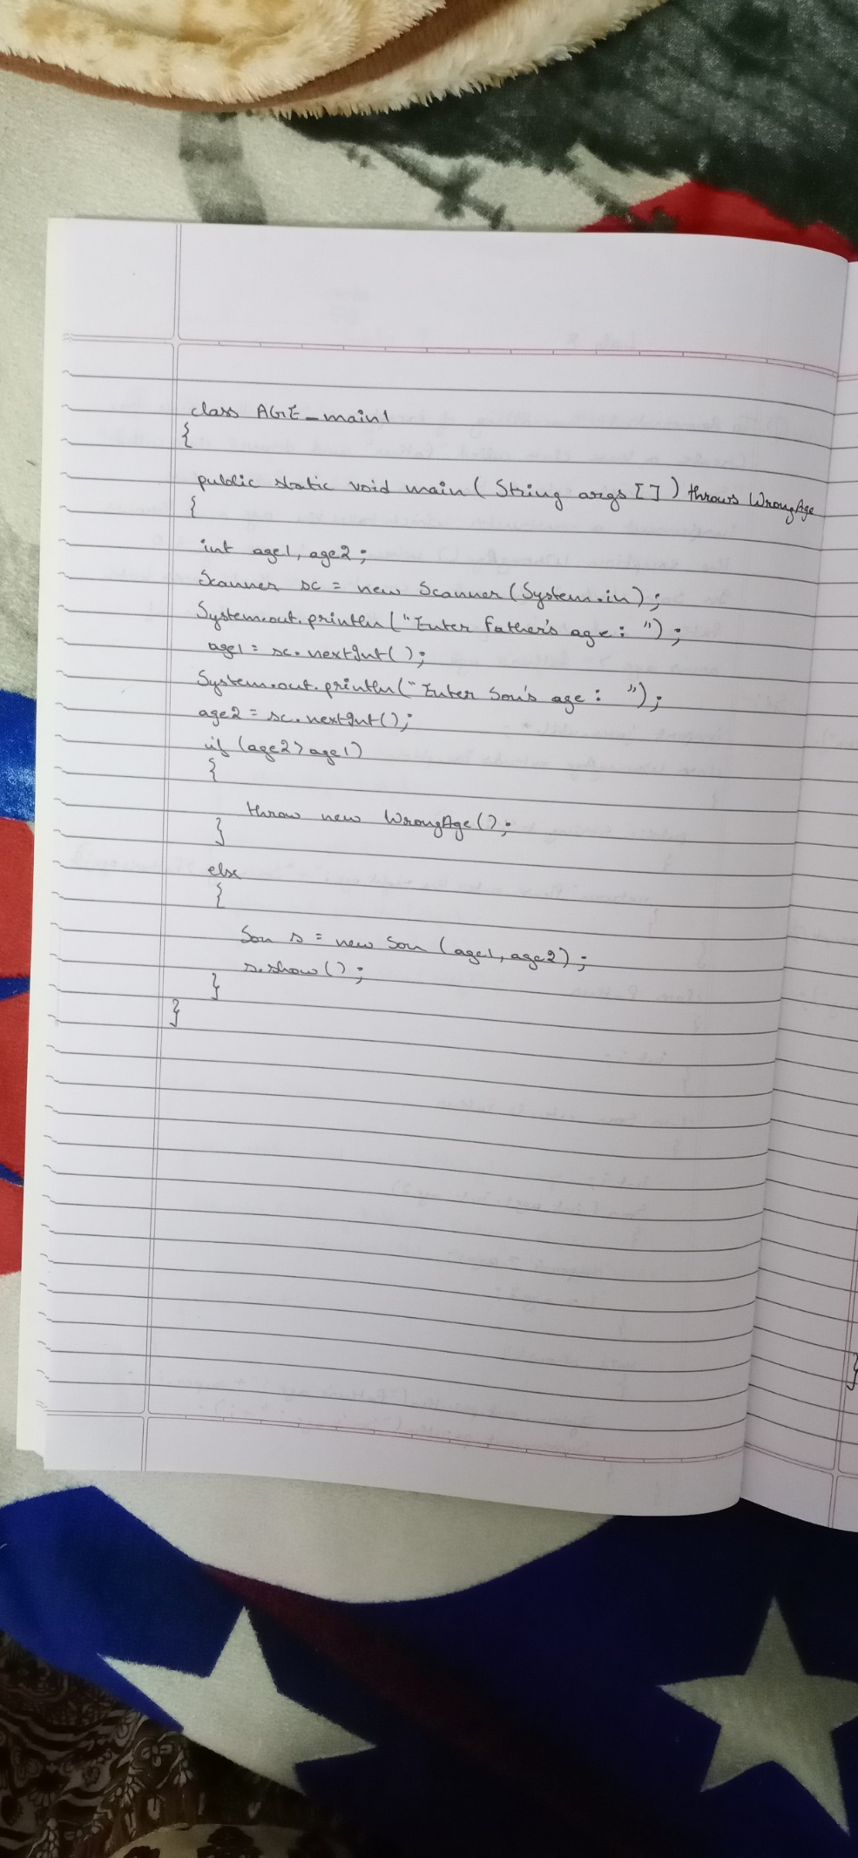

* PROGRAM

import java.util.*;

class WrongAge extends Exception

{

public String toString()

{

return "Please enter the right age:"+"Son's age > Father's age";

}

}

class Father

{

int i;

}

class Son extends Father

{

int i; //hides the i in Father class

Son(int age1,int age2)

{

super.i=age1; //i in Father class

i=age2;

}

void show()

{

System.out.println("Father's age:"+super.i);

System.out.println("Son's age:"+ i);

}

}

class AGE_main1

{

public static void main(String args[]) throws WrongAge

{

int age1,age2;

Scanner sc = new Scanner(System.in);

System.out.println("Enter Father's age:\n");

age1=sc.nextInt();

System.out.println("Enter Son's age:\n");

age2=sc.nextInt();

if(age2>age1)

{

throw new WrongAge();

}

else

{

Son s=new Son(age1,age2);

s.show();

}

}

}

* OUTPUT

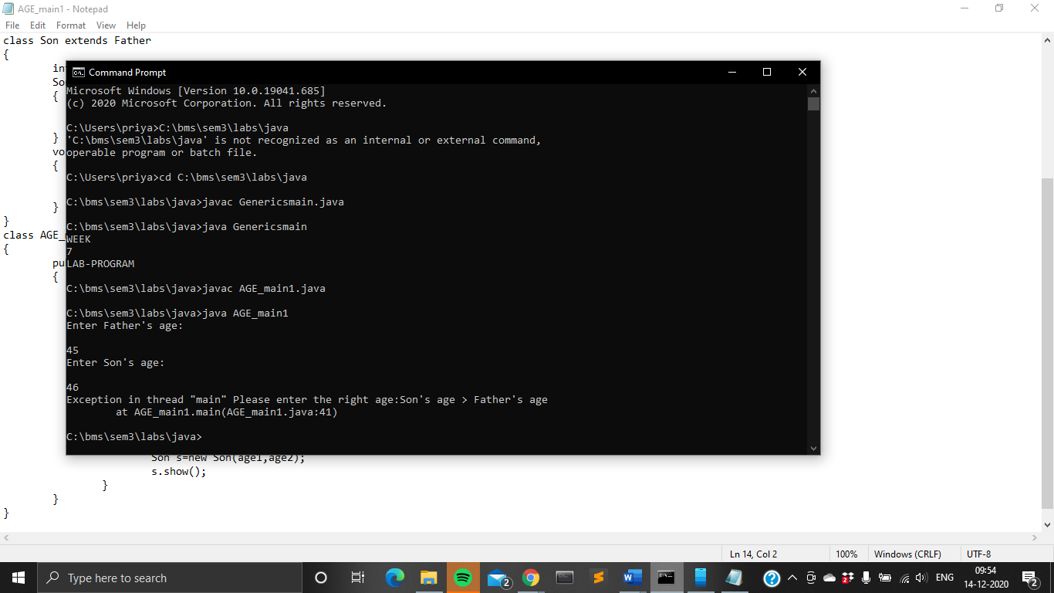

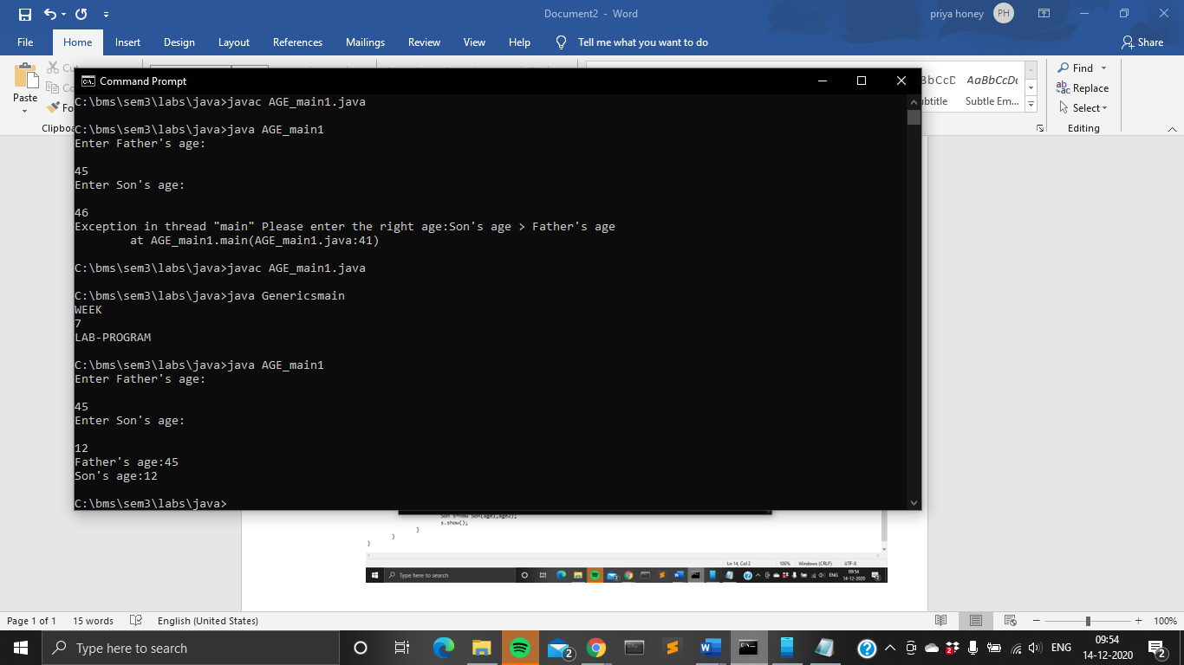

**LAB PROGRAM 9**

Write a program which creates two threads, one thread displaying “BMS College of Engineering” once every ten seconds and another displaying “CSE” once every two seconds.

* HANDWRITTEN PROGRAM

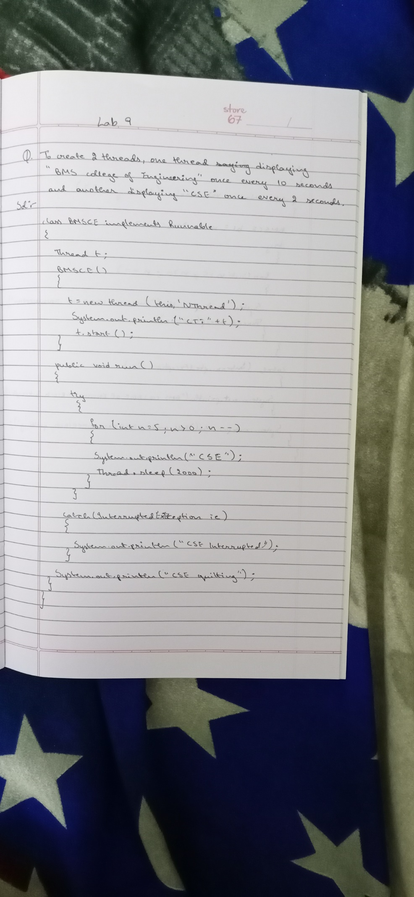

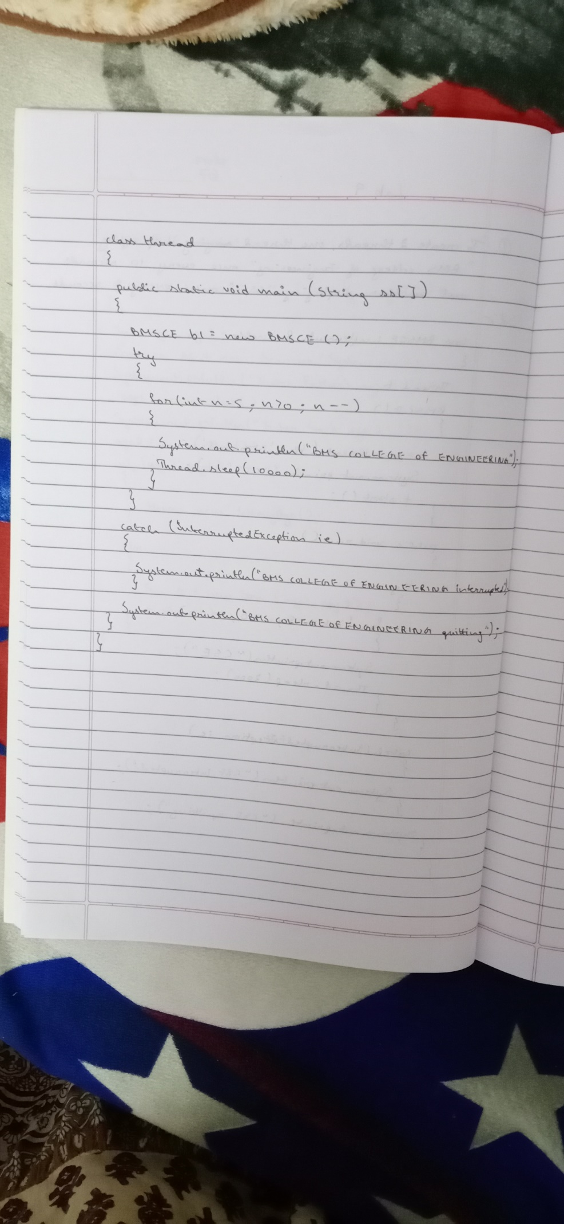

* PROGRAM

class BMSCE implements Runnable

{ Thread t;

BMSCE()

{

t=new Thread(this, "NThread");

System.out.println("CT:"+t);

t.start();

}

public void run()

{

try

{

for(int n=5;n>0;n--)

{

System.out.println("CSE");

Thread.sleep(2000);

}

}

catch(InterruptedException ie)

{

System.out.println("CSE Interrupted");

}

System.out.println("CSE quitting");

}

}

class thread

{

public static void main(String ss[])

{

BMSCE b1=new BMSCE();

try

{

for(int n=5;n>0;n--)

{

System.out.println("BMS COLLEGE OF ENGINEERING");

Thread.sleep(10000);

}

}

catch(InterruptedException ie)

{

System.out.println("BMS COLLEGE OF ENFINEERING interrupted");

}

System.out.println("BMS COLLEGE OF ENFINEERING quitting");

}

}

* OUTPUT

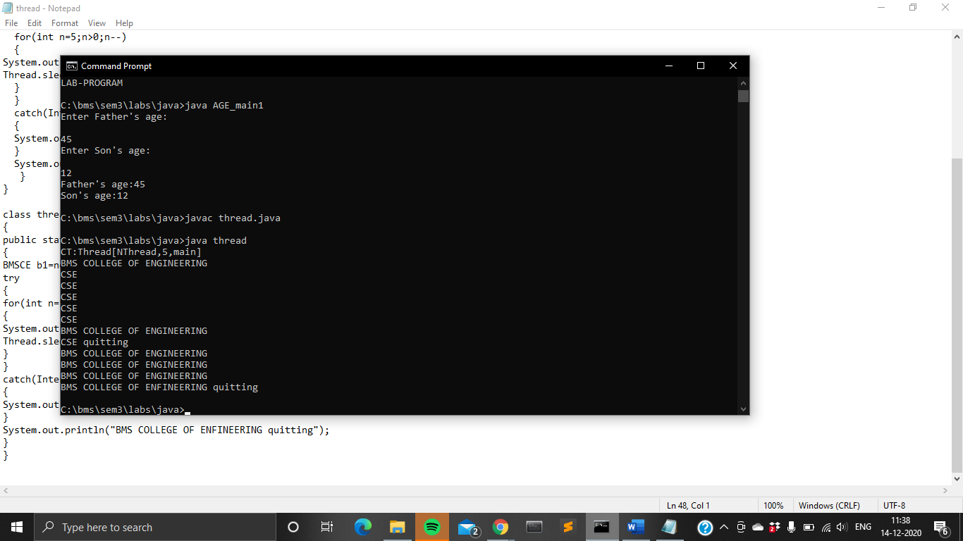

**LAB PROGRAM 10**

Write a program that creates a user interface to perform integer divisions. The user enters two numbers in the text fields, Num1 and Num2. The division of Num1 and Num2 is displayed in the Result field when the Divide button is clicked. If Num1 or Num2 were not an integer, the program would throw a NumberFormatException. If Num2 were Zero, the program would throw an Arithmetic Exception Display the exception in a message dialog box.

* HANDWRITTEN PROGRAM

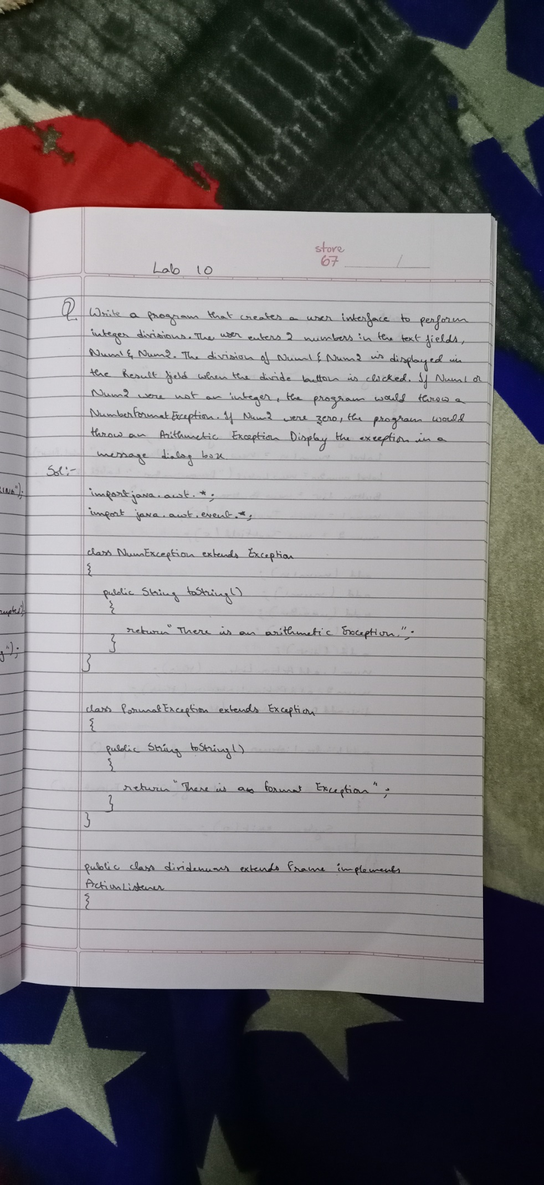

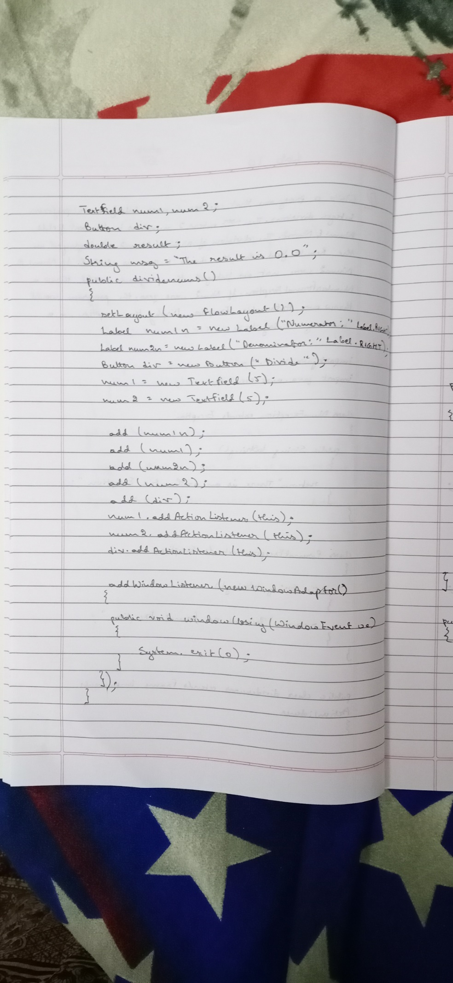

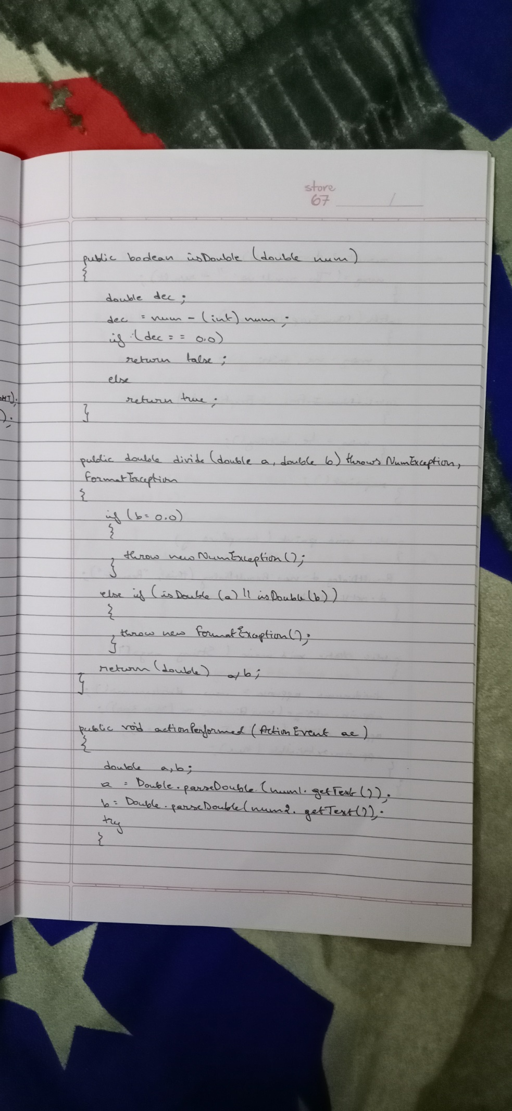

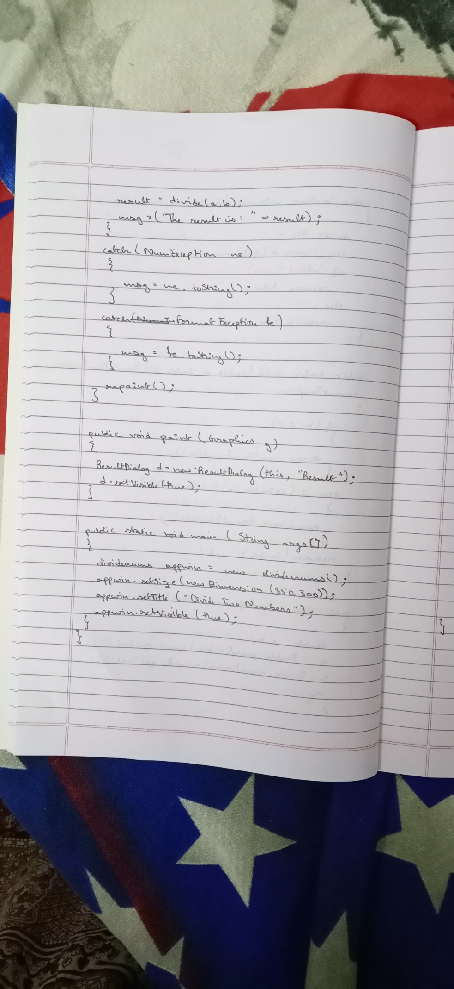

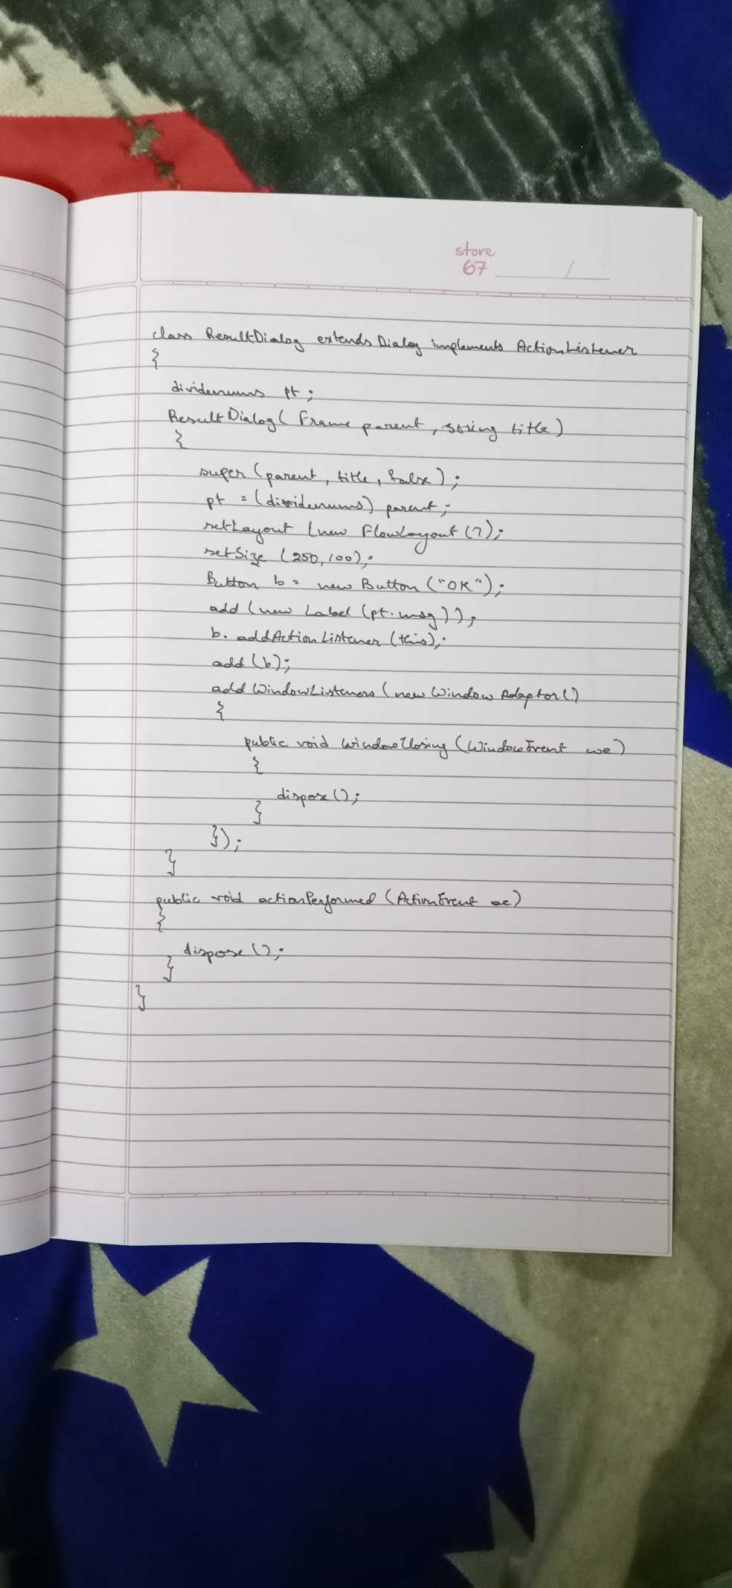

* PROGRAM

import java.awt.*;

import java.awt.event.*;

class NumException extends Exception

{

public String toString()

{

return "There is an Arithmetic Exception.";

}

}

class FormatException extends Exception

{

public String toString()

{

return "There is an Format Exception.";

}

}

public class dividenums extends Frame implements ActionListener

{

TextField num1,num2;

Button div;

double result;

String msg="The result is: 0.0";

public dividenums()

{

setLayout(new FlowLayout());

Label num1n= new Label("Numerator: ",Label.RIGHT);

Label num2n= new Label("Denominator: ",Label.RIGHT);

Button div= new Button("Divide");

num1=new TextField(5);

num2=new TextField(5);

add(num1n);

add(num1);

add(num2n);

add(num2);

add(div);

num1.addActionListener(this);

num2.addActionListener(this);

div.addActionListener(this);

addWindowListener(new WindowAdapter()

{

public void windowClosing(WindowEvent we)

{

System.exit(0);

}

});

}

public boolean isDouble(double num)

{

double dec;

dec=num-(int)num;

if(dec==0.0)

return false;

else

return true;

}

public double divide(double a, double b) throws NumException, FormatException

{

if(b==0.0)

{

throw new NumException();

}

else if(isDouble(a) || isDouble(b))

{

throw new FormatException();

}

return (double) a/b;

}

public void actionPerformed(ActionEvent ae)

{

double a,b;

a=Double.parseDouble(num1.getText());

b=Double.parseDouble(num2.getText());

try

{

result=divide(a,b);

msg=("The result is: "+result);

}

catch(NumException ne)

{

msg=ne.toString();

}

catch(FormatException fe)

{

msg=fe.toString();

}

repaint();

}

public void paint(Graphics g)

{

ResultDialog d=new ResultDialog(this, "Result");

d.setVisible(true);

}

public static void main(String args[])

{

dividenums appwin= new dividenums();

appwin.setSize(new Dimension(350,300));

appwin.setTitle("Divide Two Numbers");

appwin.setVisible(true);

}

}

class ResultDialog extends Dialog implements ActionListener

{

dividenums pt;

ResultDialog(Frame parent,String title)

{

super(parent,title,false);

pt=(dividenums)parent;

setLayout(new FlowLayout());

setSize(250,100);

Button b=new Button("OK");

add(new Label(pt.msg));

b.addActionListener(this);

add(b);

addWindowListener(new WindowAdapter()

{

public void windowClosing(WindowEvent we)

{

dispose();

}

});

}

public void actionPerformed(ActionEvent ae)

{

dispose();

}

}

* OUTPUT

